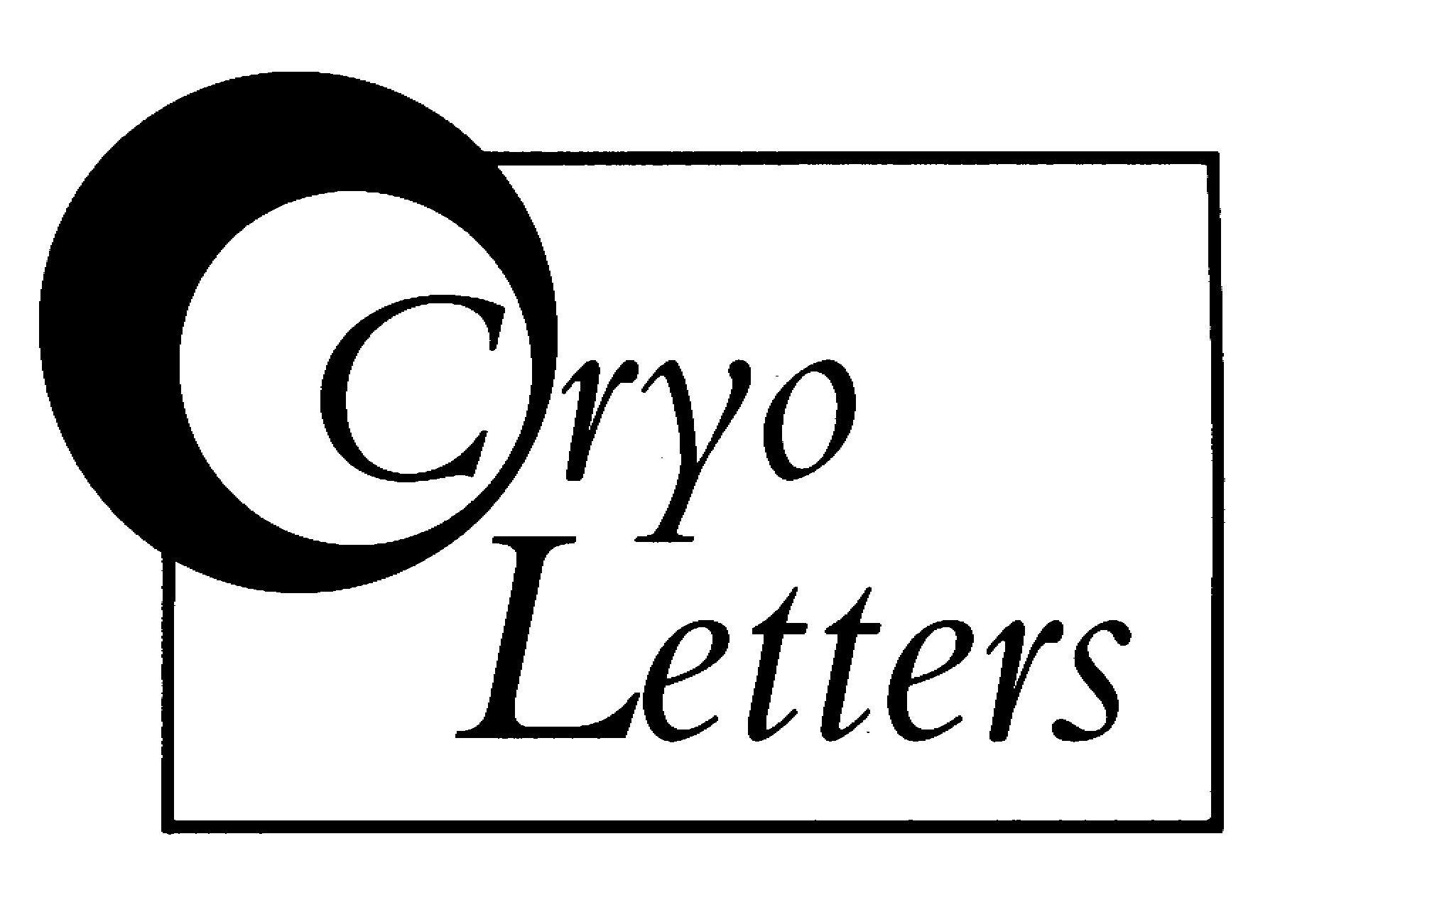
Hugh Pritchard - Executive Editor
CryoLetters LLP,
c/o 73 Highdown Road, Lewes, UK
Email: editor@cryoletters.org

DECLARATION AND COPYRIGHT TRANSFER
In the event of non-acceptance by CryoLetters this document becomes null and void.
CL Ref No:

Declaration
The Undersigned hereby affirm that this manuscript article represents original, unpublished material that is not under editorial consideration elsewhere, in whole or in part, and that each author has participated sufficiently in the intellectual content, analysis of data (if applicable) and writing of the manuscript to take public responsibility for it. The undersigned also attest that those individuals or institutions in the acknowledgements are aware that their names appear.

Copyright transfer and conditions of publication
The undersigned authors, jointly and severally, relinquish to CryoLetters all control over this material such as rights to make or authorise reprints, to reproduce the materials in other forms, and to grant the material to others without charge. The undersigned grant and assign exclusively to CryoLetters for its use in any and all rights of whatsoever kind or nature now or hereafter protected by the copyright laws (common or statutory) in England and all foreign countries in all languages in and to the above-named article, including all subsidiary rights.
CryoLetters grants to each author the right to republication in any book of which he/she is the author or editor, subject only to giving proper credit in the book to the original journal publication of the article by CryoLetters. CryoLetters also grants to the author(s) the right to use the .pdf of the published article for personal, academic and Institutional purposes, including making copies for own personal use, for teaching, for distribution to colleagues (but not commercially or systematically, e.g. via e-mail list or list server), to present and distribute the article to colleagues at meetings or symposia (in a non-commercial way), and to post the details of the article on an individual or Institutional web site with a link to the journal web page, and to Ingenta, our on-line access provider.

Title of Article:
Authors: Name (Please print): Signed: Date:

(All authors should sign, or if not, it will be assumed that all authors have given their consent and have been informed of this undertaking on their behalf)

